# Lab 4: if Statement - Choose a Shape and Display it

Academic Honesty

* The work you turn in is to be your work, not copied from someone else, from the web, or generated by a program.
* Never allow anyone access to your files.
* Never give anyone your password.
* Never share your USB memory or email your files to anyone else.
* Never give anyone a printed copy of your file or an electronic copy.
* Never allow anyone to copy your work.

Purpose

This lab will let us practice writing if statements along with graphics.

## Functionality

* Ask the user to enter a shape: tree, boat, or star
* If the user enters one of the three shapes, then draw that shape
* Make sure your if statement is case insensitive and space insensitive.
* If the user enters text that is not recognized, then present them with an error message.

## Sample Program with Valid User Data

Program first asks the user to enter a shape:

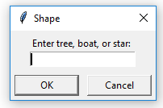

Then the program draws the shape they entered using turtle graphics. Your shape should look like the ones below. Make sure to fill them in.

|  |  |  |
| --- | --- | --- |
|  |  |  |

## Sample Program with Invalid User Data

Assuming the user entered car.

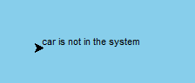

## Submitting your files

* Copy your .py file and move it to your X:\101Labs directory for grading.
* Make sure your file is named Lab4XY.py where XY are your initials
* Print your code, and submit it to your lab instructor at the beginning of your next lab class.

## Grade Breakdown

|  |  |
| --- | --- |
| **Points** | **Expectation** |
| 10% | Comments, listing program, your name, and explaining the code. Code should be easy to understand because of the comments. |
| 10% | Correctly gathering user input |
| 30% | If statement to test shapes |
| 50% | Correctly draw a shapes |